**Cloud Computing Final Paper**

**Muhammad Hamza (CS191076) 8A**

**Give the link of repository in the document you have created**

1. **Upload your image on S3 Bucket and create a Resume HTML file in your AWS Instance (EC2) and add your image link in the Resume file**

a) Uploading Image on S3 bucket

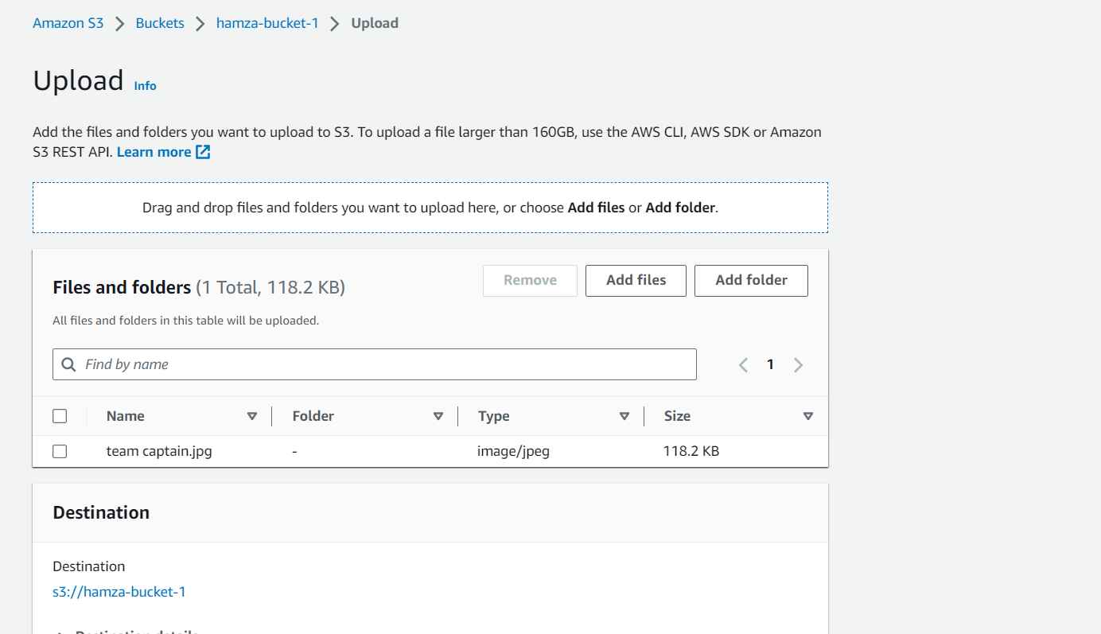

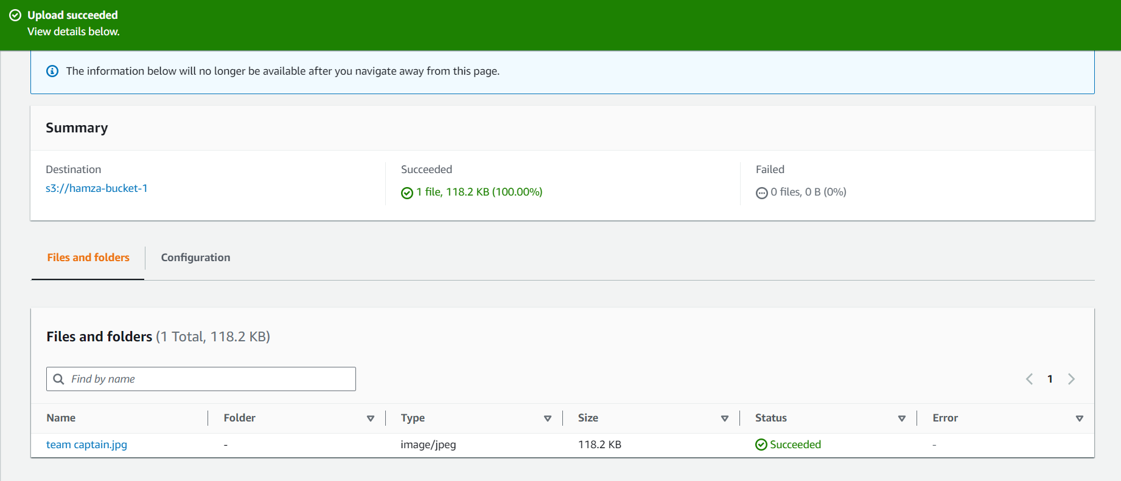

b) Add your image link in the Resume file.

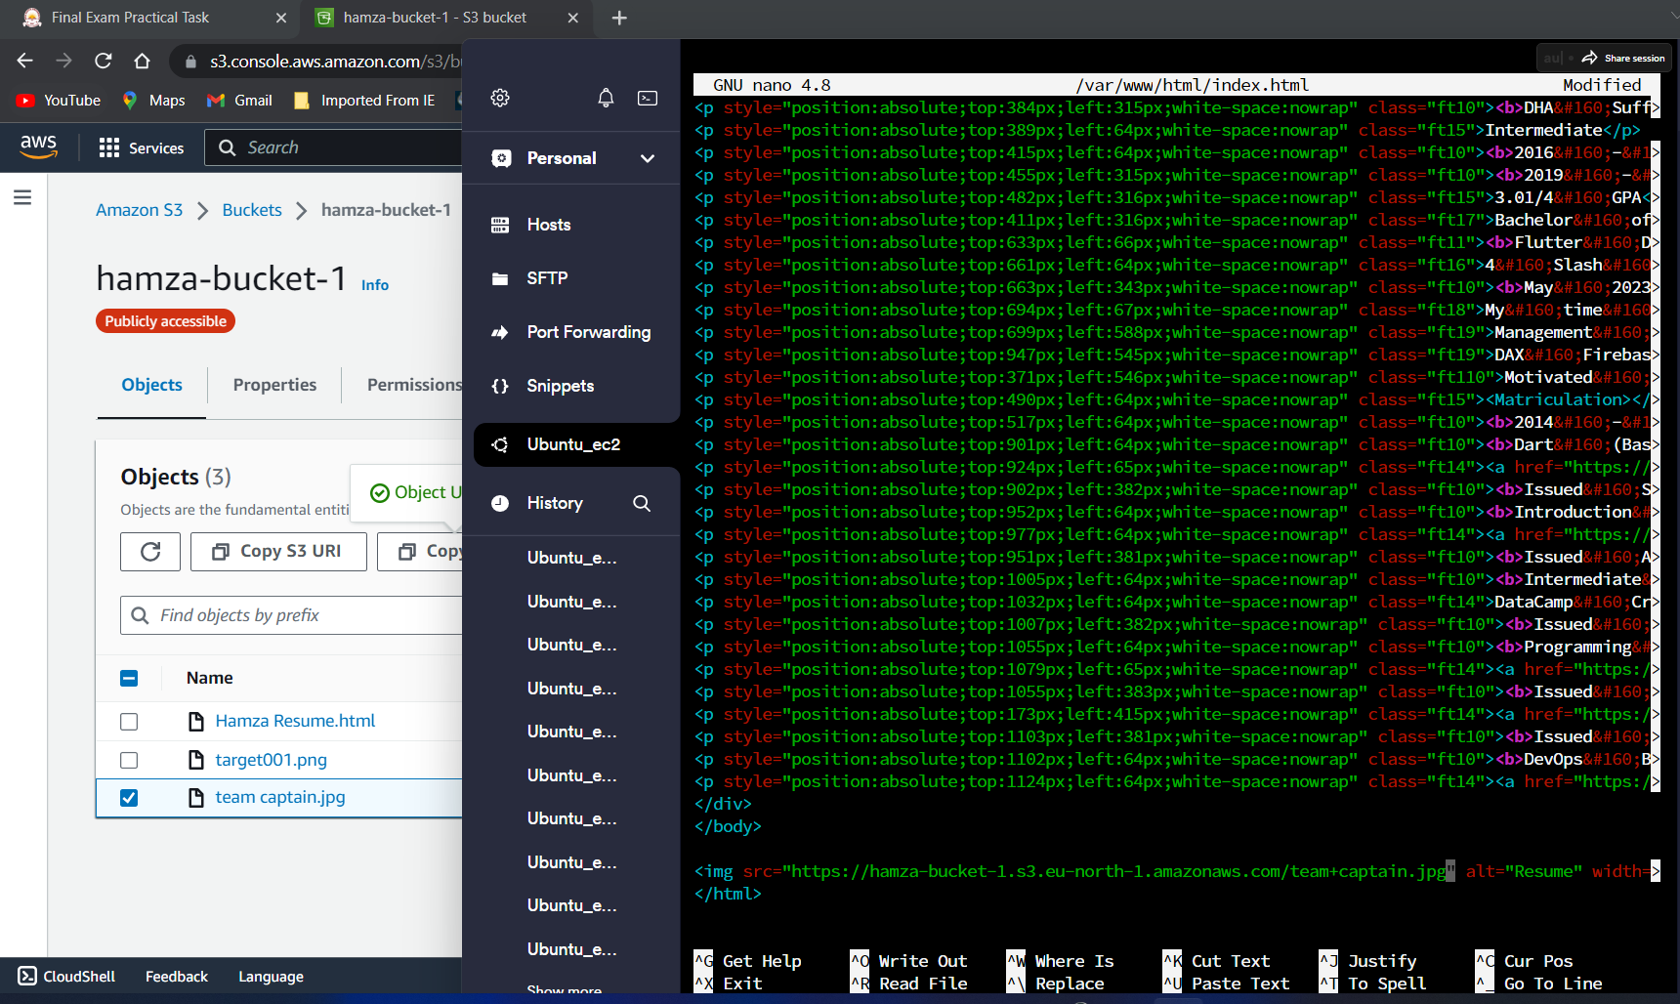

c) Now I am choosing 8084 port to run my website of resume on my public ip address.

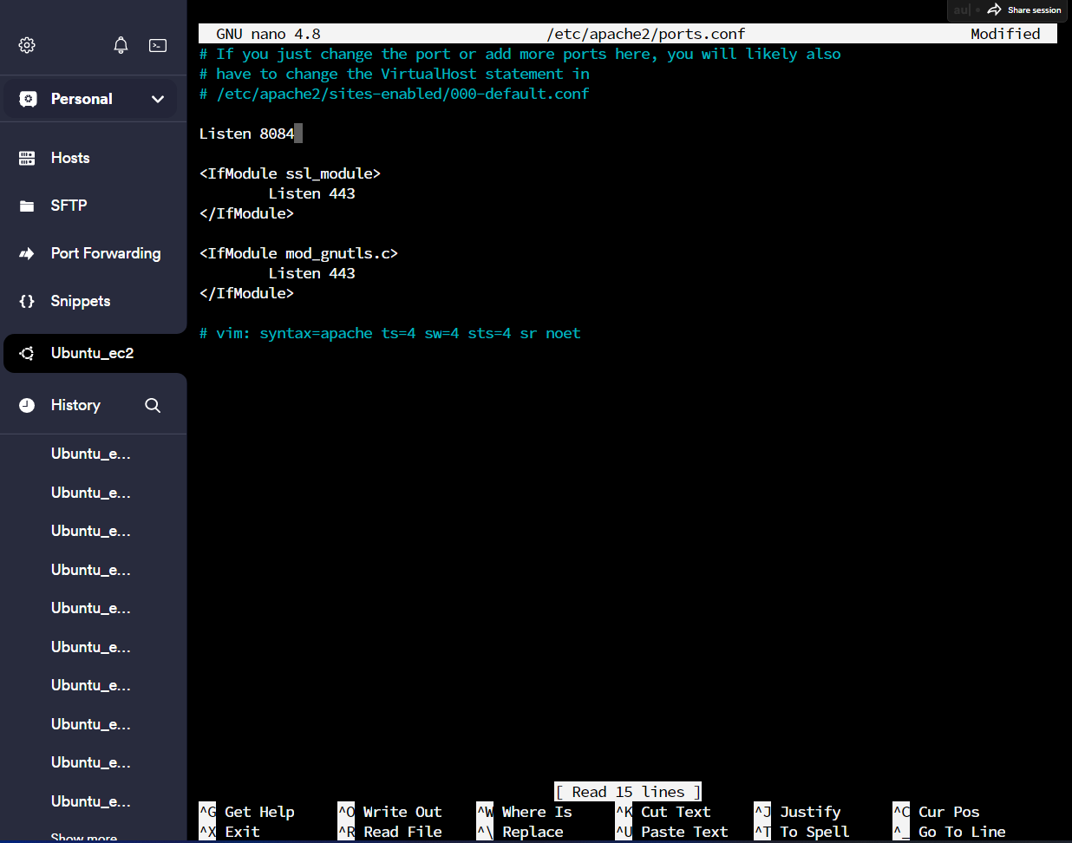

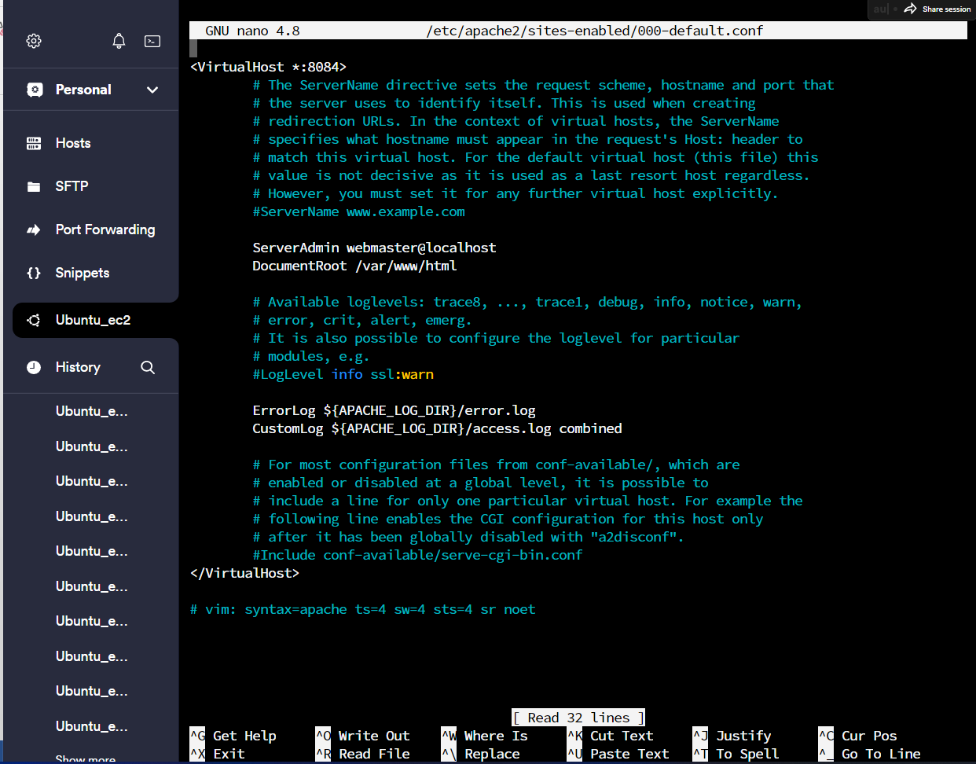

d) Now, Restart your apache2 server to listen the new IP you have define.

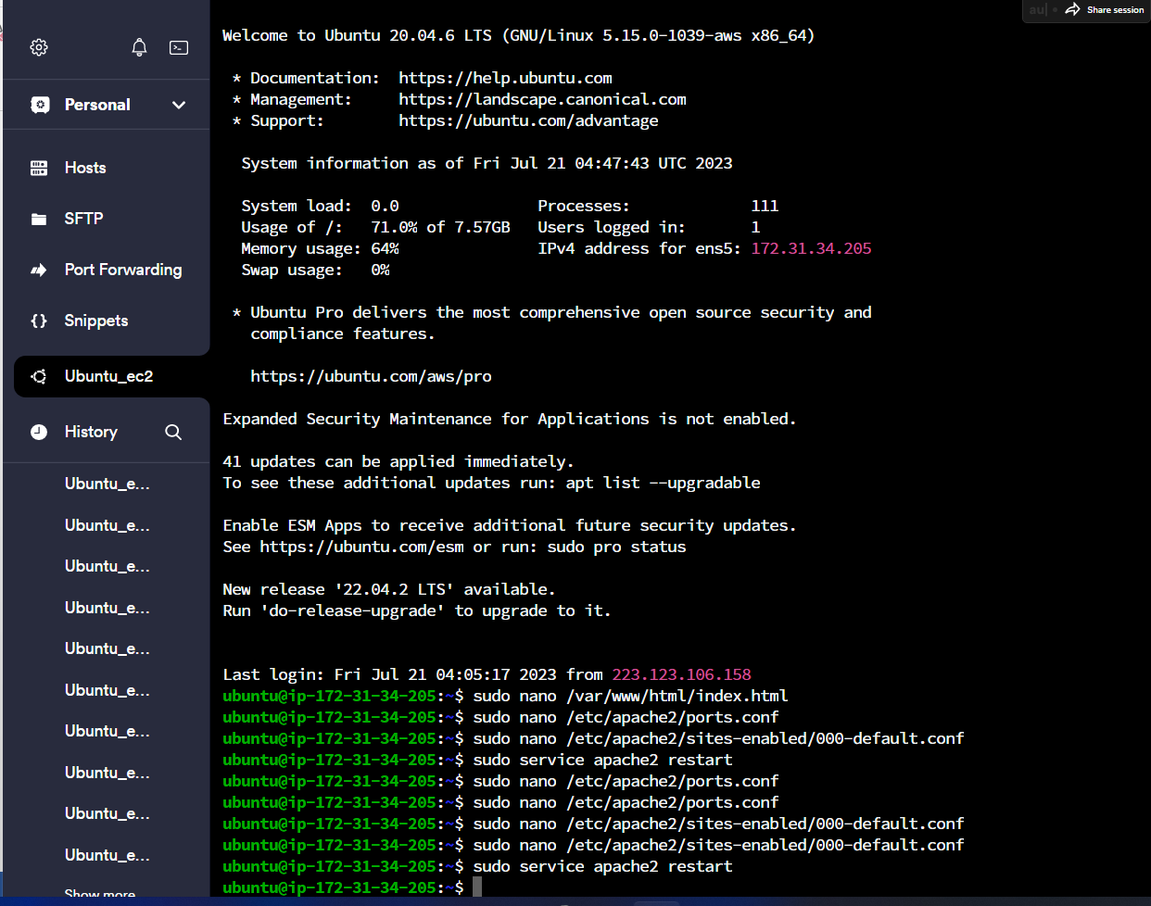

Here is final output. You can check on the given IP link: http://16.171.37.209:8084/

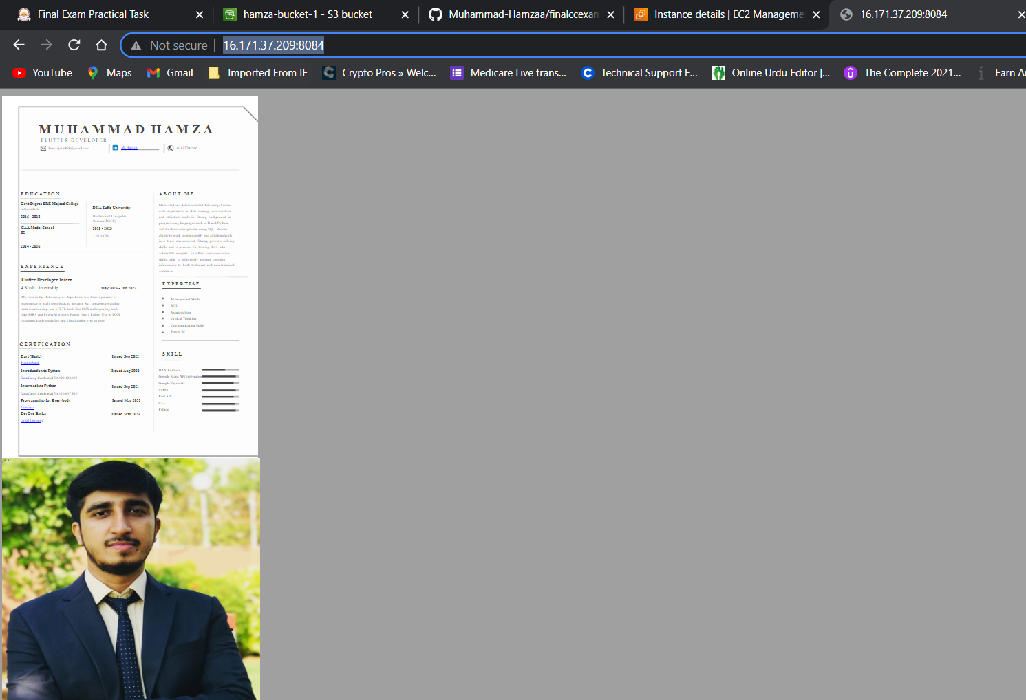

2. **Git**

Create a repository on git

Upload html Resume file link in the repository.

Create two branches

Write different functions in each branch

Merge branches

Revert changes

Merge only the first branch again